

Introduction to Microsoft Office 365

Prateek Panwar

|  |  |  |
| --- | --- | --- |
|  | INDEX |  |
| Chapter | Title | Page |
| 1 | Introduction to Microsoft Word | 3 |
| 2 | Introduction to Microsoft Excel | 33 |
| 3 | Introduction to Microsoft PowerPoint | 45 |

Chapter I

Introduction to Microsoft Word

Introduction

Microsoft word is most popular word processing software. It was first released on 25 October 1983 under the name Multi-Tool word for Xenix systems. And it came under package Microsoft Office with other software. It is commonly referred as MS Word which stands for Microsoft Word.

MS Word enables you to create, edit and print documents with many powerful features and functionality. It has several time saving language features like spell checker, Find and Replace. It helps finding and correcting grammatical errors in few clicks. Besides general typing documents, Word offers its users to make their documents more appealing by allowing them to add Images, shapes, designing background, adding word art which allows to design selected text visually. Functionality wise. It allows users to print their documents and share in different formats like .pdf, .rtf, .txt which are more widely used and work on other devices.

Word is proprietary software which is offered with Microsoft Office through a purchasable perpetual lifetime license or through a subscription-based service like Microsoft 365. It is available in several devices including Microsoft Windows, IOS, Android, IBM systems, Apple Mac, AT&T Unix PC, SCO Unix OS/2.

Menu Bar

The Menu bar is generally found directly below Title bar. The Menu bar displays the menu. The Menu bar begins with button File and continues with Home, Insert, Design, Layout, References, Mailings, Review, View and Help. We left click by mouse on a desired button and it brings its options of selected button on the ribbon under Menu bar.

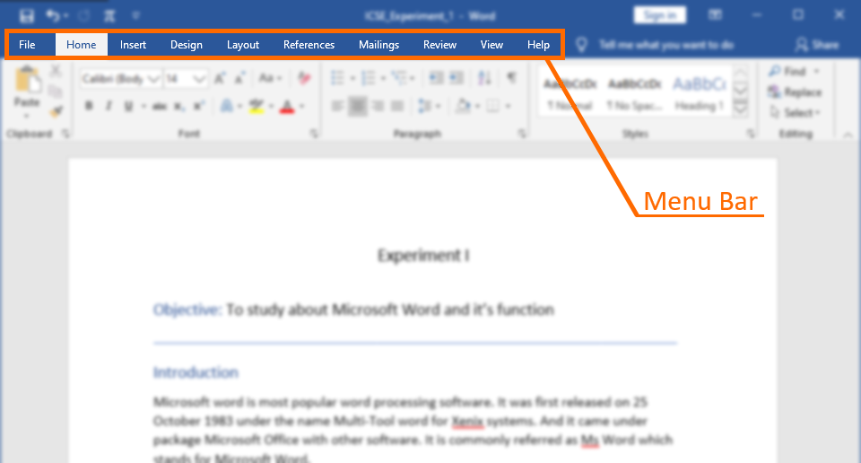

After user has clicked on desired button on Menu bar, it brings variety of options and tools below on the ribbon. For example, here we clicked on Insert Menu and it brought Insert options and tools on ribbon which is below Menu bar.

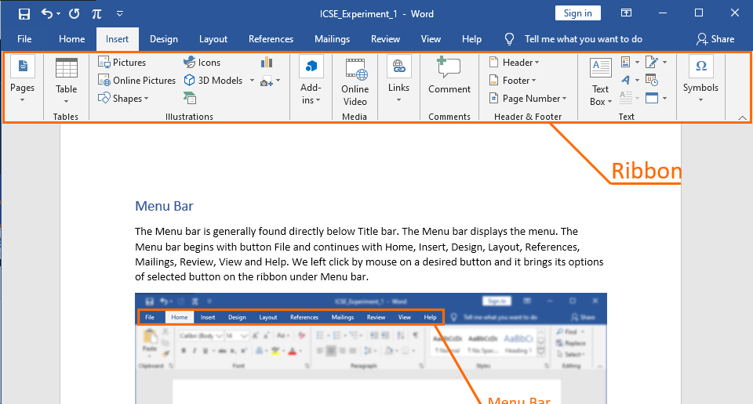

Creating Documents

Follow the steps below to create a document.

1. On Menu Bar, Click on File Tab

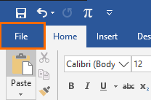

1. Click on New and select a desired template. For ex: Blank document
2. Press Create or enter

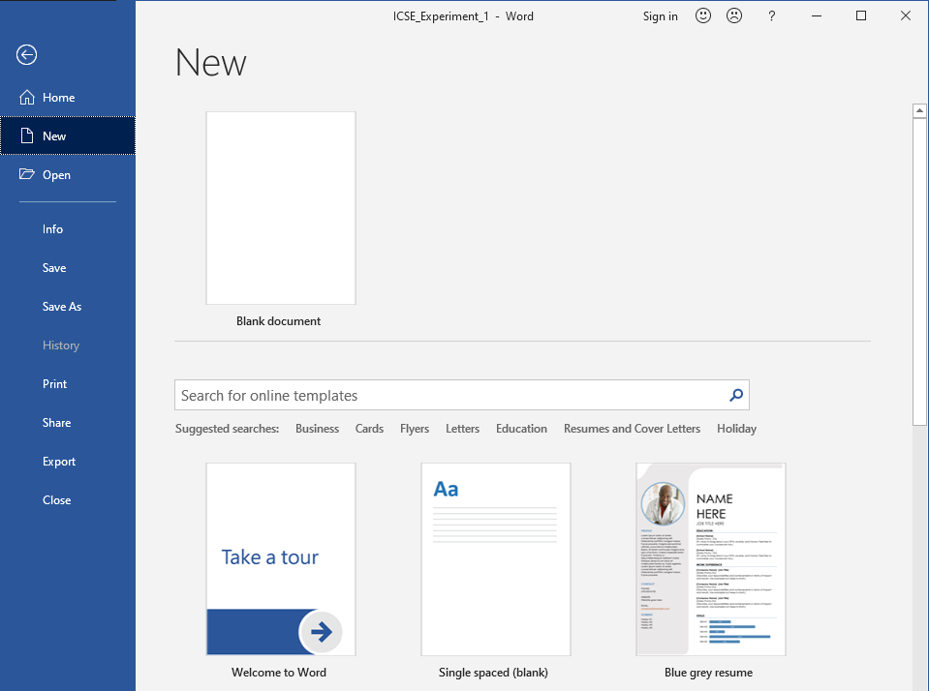

Using Templates

About Template:

Many times, we make same type of document with a heading, page setup same as before. We don’t have to remake all that again. Templates allows you to open a pre-defined document with same setup as you use often.

Create a Template:

To create a template:

1. Click on File then Save-As then click on Browse
2. Locate your desired location and enter name of Template
3. In the drop-down menu, Select Word Template instead of Word document and click Save.

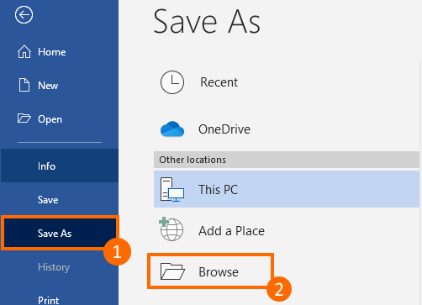

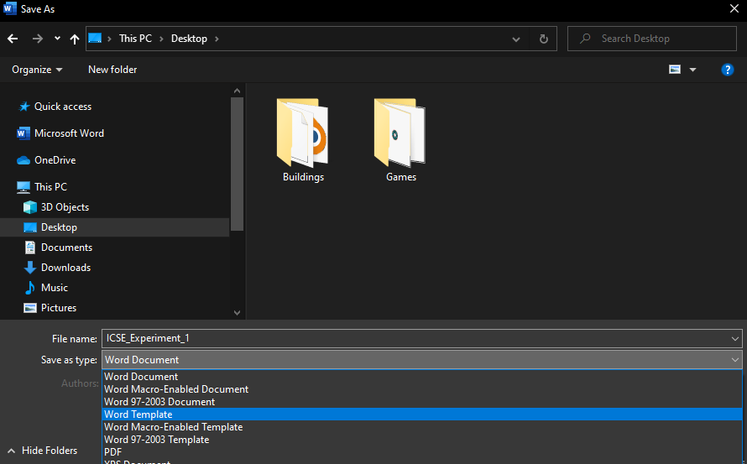

Edit a Template:

To edit a template:

1. Open it through either File > Open or double click the file
2. Make desired changes you want in template and save it through save icon at title bar or through a shortcut Ctrl + S

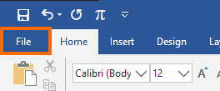

Open your Template:

To open your custom template:

1. Click File > New
2. Select Personal for custom template
3. Click on a custom template

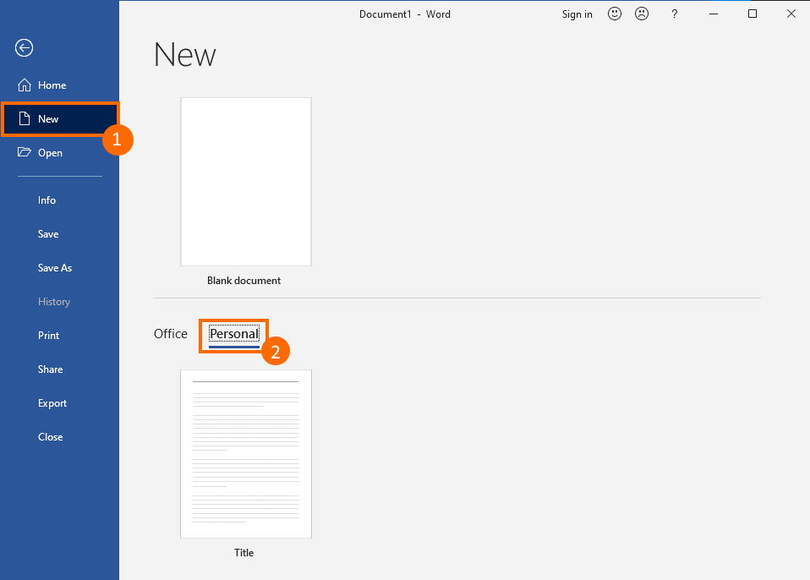

Saving Documents

To save a document in order to use it later. We can save in two ways:

1. Save: It is used to simple save as default word file with extension .docx
2. Save As: It is used to save as a different format in order to use it in other software besides word

Save a document:

1. Click on File button in Menu bar
2. Click on Save option
3. If your document isn’t saved before, it will change to Save As
4. If your document is already saved before, it will update saved document



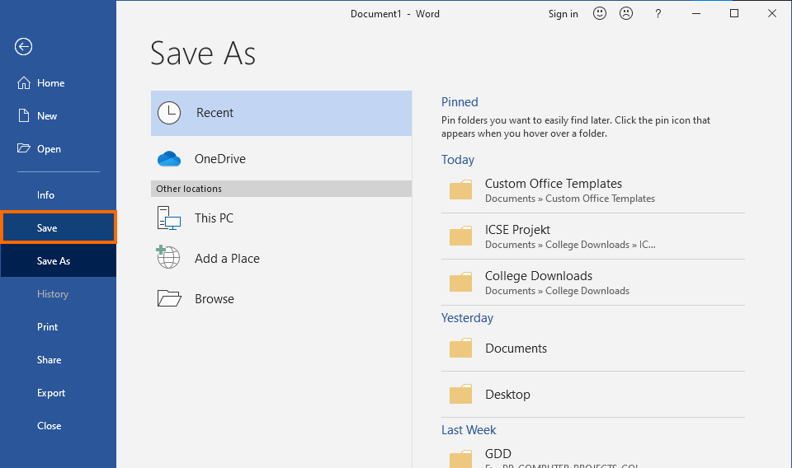

Save as document:

1. After navigating through Save As menu
2. Click on Browse to save in a different location
3. A dialog box will appear
4. In the box, navigate to your desired location
5. Enter the name of File
6. Select the format of document
7. Click Save As

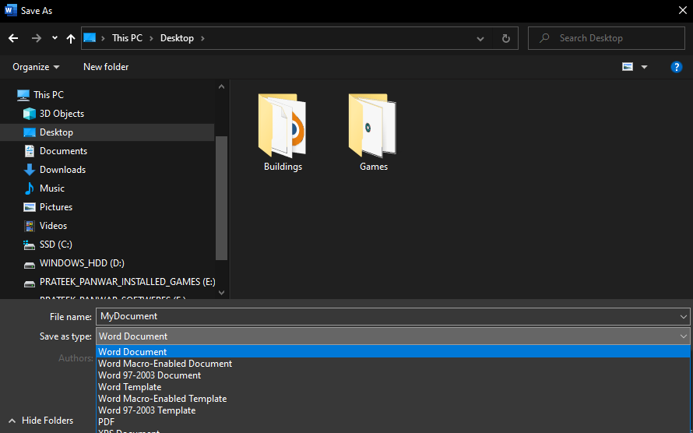

Working with Documents

To create and design effective documents, you need to know how to format

text. In addition to making your document more appealing, formatted text

can draw the reader's attention to specific parts of the document and help

communicate your message.

To format font size:

1. Keep Left clicking and drag over the text to select text
2. On Home in Menu bar, Click on Size up button to increase size and size down to reduce size
3. To change size quickly, click on drop down menu and select needed size

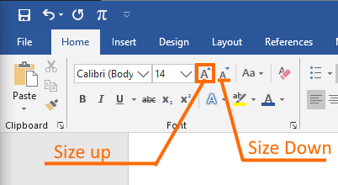

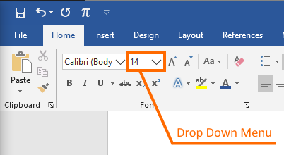

To format font style:

1. Select the text you want to modify
2. Left-click the drop-down arrow next to the font style box on the Home

tab. The font style drop-down menu appears

1. Move your cursor over the various font styles. A live preview of the font

will appear in the document.

1. Left-click the font style you want to use. The font style will change in the

document.

To format font color:

1. Select the text you want to modify
2. Left-click the drop-down arrow next to the font color box on the Home

tab. The font color menu appears

1. Select the color

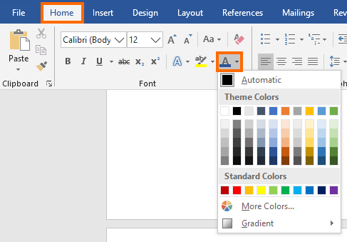

To use the Bold, Italic and Underline commands:

1. Select the text you want to modify
2. Click on Bold, Italic and Underline Buttons shown

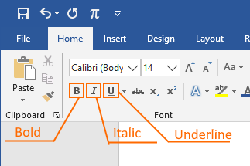

To change text case:

1. Select the text you want to modify
2. Click the change case command in Font group on the Home tab
3. Select one of the case options from the list

To change text alignment:

1. Select the text you want to modify
2. Select one of the four alignment options from the Paragraph group on

the Home tab.

• Align Text Left: Aligns all of the selected text to the left margin

• Center: Aligns text an equal distance from the left and right

margins

• Align Text Right: Aligns all of the selected text to the right margin

• Justify: Aligns text equally to the right and left margins; used in

many books, newsletters, and newspapers.

Setting up Pages of Document

While creating your document we need to make sure whether to make adjustments to the layout of the page. The page layout affects how content appears and includes the page's orientation, margins, and size. It is important for printing document later.

Page Orientation:

Word offers two-page orientation options: landscape and portrait. Landscape means the page is oriented horizontally, while portrait means the page is oriented vertically. Compare our example below to see how orientation can affect the appearance and spacing of text and images.

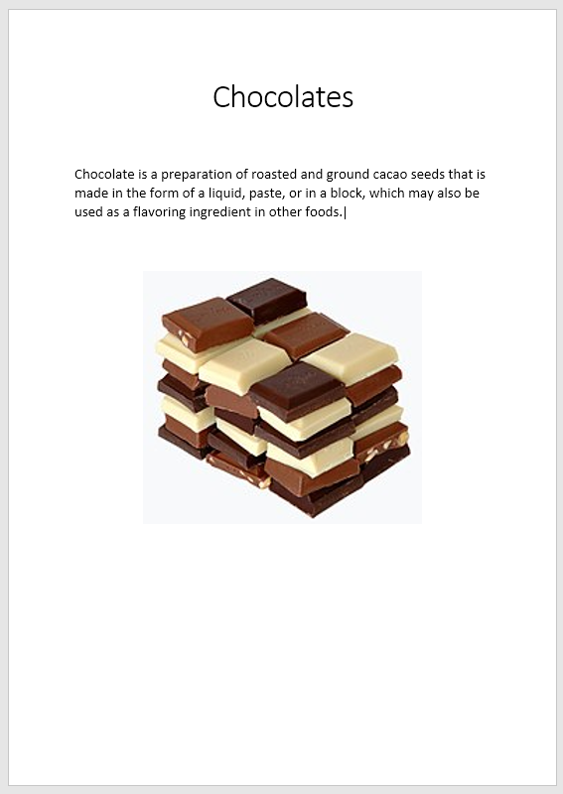

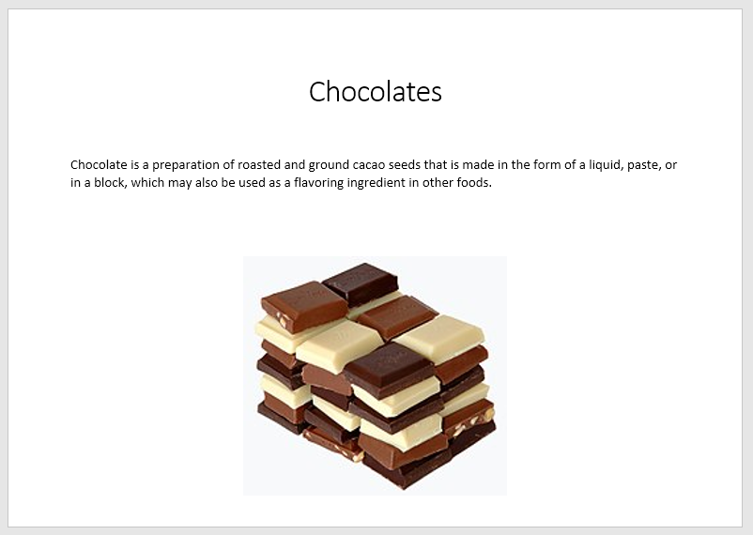

Portrait Landscape

To change page orientation:

1. Select the Page Layout tab
2. Click the Orientation command in the Page Setup group
3. From the drop-down menu, Select either Portrait or Landscape

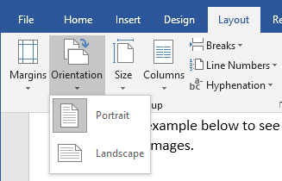

Page margins:

A margin is the space between the text and the edge of your document. By default, a new document's margins are set to Normal, which means it has a one-inch space between the text and each edge. Depending on your needs, Word allows you to change your document's margin size.

To format page margins:

1. Select the Page Layout tab, then click the Margins command

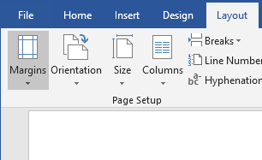

1. A drop-down menu will appear. Click the predefined margin size you

want.

1. 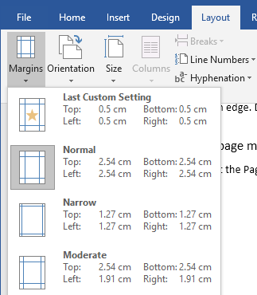Margins of the document will be changed

To use custom margins:

Word also allows you to customize the size of your margins in the Page Setup dialog box.

To change Margins:

1. From the Page Layout tab, click Margins. Select Custom Margins from the drop-down menu.
2. The Page Setup dialog box will appear.
3. 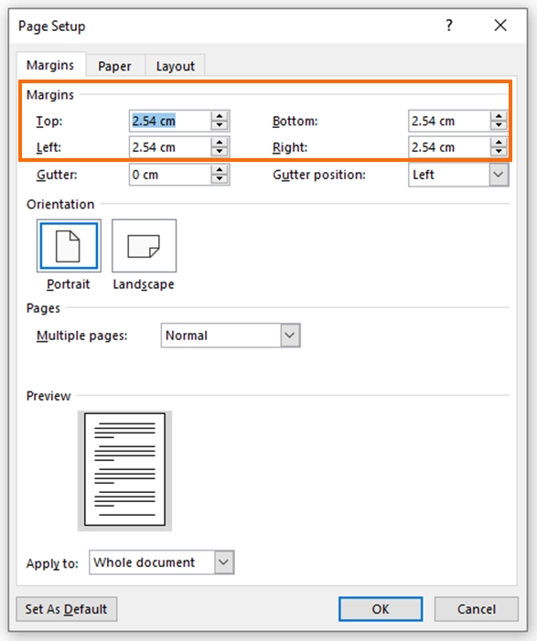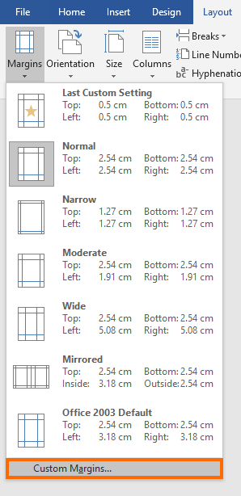Adjust the values for each margin, then click OK.

Page Size:

In Word for Mac, you can choose a predefined paper size from a list and change the paper size for all pages in your document, for a specific page, or for a specific section. You can also change the default paper size used for new documents.

To change the page size:

1. In Menu Bar, Click on Layout tab (Page Layout in older versions)
2. Select Size button
3. A drop-down menu will appear. The current page size is highlighted. Click the desired pre defined page size

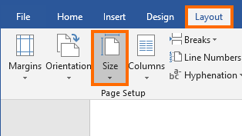

To use a custom page size:

In Word 2016 for Mac, you can also create a custom paper size and you can choose different paper sources for pages in your document. In order to do that

1. From Lauout tab, Click Size then from drop down menu click More Paper Sizes
2. The Page Setup dialog box will appear
3. 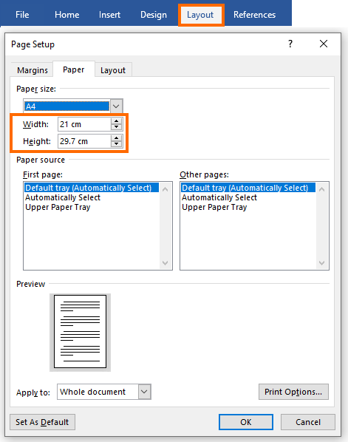Set your custom size by changing width and height and click ok

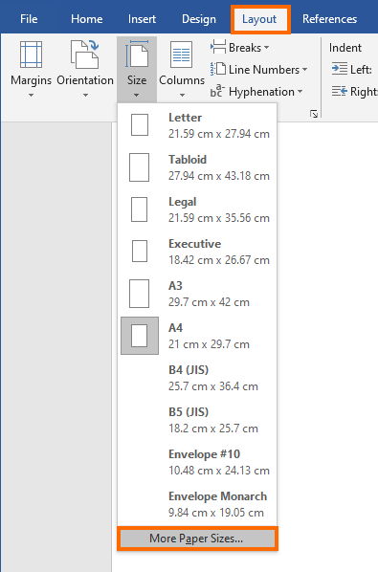

Printing a document

To print a document, Follow the below steps:

1. From Menu Bar, Click on File button and then Print Tab
2. Select the printer device and set up page size and other settings
3. Click Print



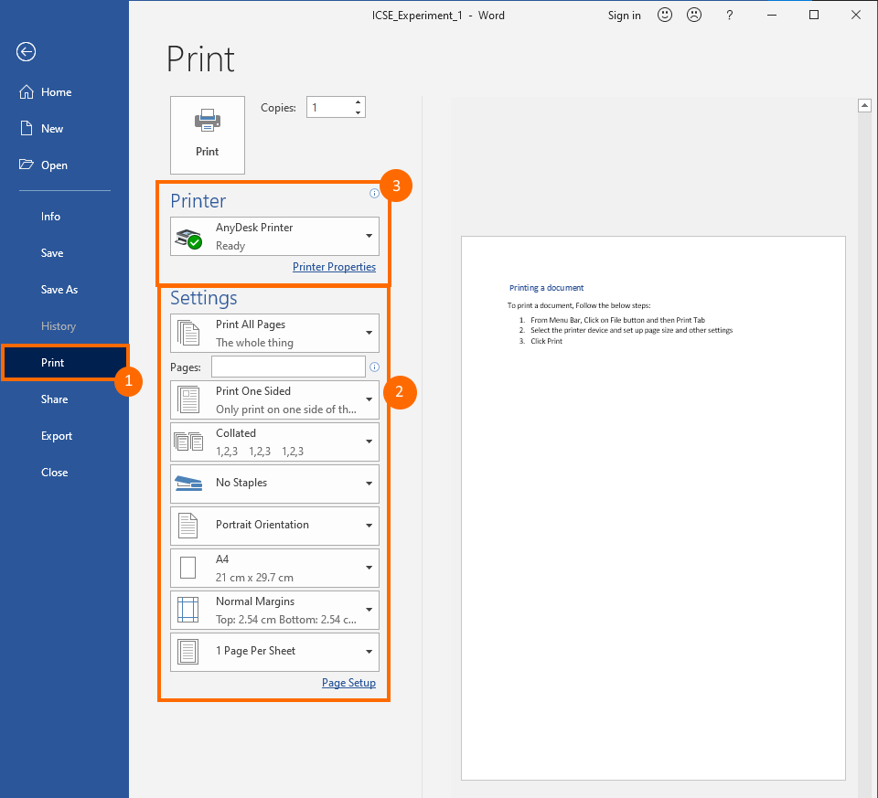

The following description of settings may be useful:

|  |  |
| --- | --- |
| SN | Options and Description |
| 1 | **Copies:** Set the number of copies to be printed. By default, you will have one copy of the document. |
| 2 | **Print Custom Range:** This option is used to print a particular set of pages of the document. Type the number in Pages option, if you want to print all the pages from 2 up to 5 then you would have to specify this option as 2-5 and Word will print only 2nd, 3rd, 4th and 5th pages. |
| 3 | **Print One Sided:** By default, you print one side of the page. There is one more option where you will turn up your page manually in case you want to print your page on both sides of the page. |
| 4 | **Collated:** By default, multiple copies will print Collated; if you are printing multiple  copies and you want the copies uncollated, select the Uncollated option. |
| 5 | **Orientation:** By default, page orientation is set to Portrait; if you are printing your  document in landscape mode then select the Landscape mode. |
| 6 | **A4:** By default, the page size is A4, but you can select other page sizes available  in the dropdown list. |
| 7 | **Custom Margin:** Click the Custom Margins dropdown list to choose the document margins you want to use. For instance, if you want to print fewer pages, you can  create narrower margins; to print with more white space, create wider margins. |
| 8 | **1 Page Per Sheet:** By default, the number of pages per sheet is 1 but you can print multiple pages on a single sheet. Select any option you like from the given dropdown list by clicking over the 1 Page Per Sheet option. |

Using tables and columns

Tables are a good way to represent information in more organized way. Tables makes reading and understanding analytical data much easier. Word also allows users to create tables of various design. Let’s see how:

Insert Table:

To insert Table:

1. From Menu Bar, Click Insert Tab

2. Click Table button, A drop down menu will appear. From menu, Click Insert Table

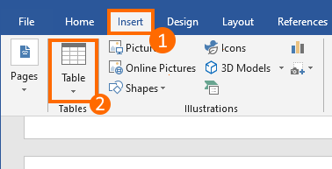

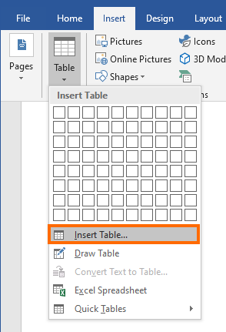

3. After that, Insert Table dialog will appear. Enter number of Rows and columns you want in your table and click ok. The table will be created.

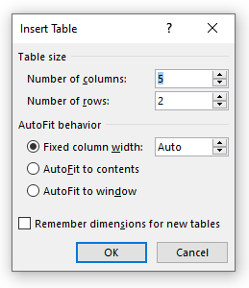

Add and Delete Rows and Columns in Table:

1. After Table is created, point your mouse pointer over it and right click. The context menu will appear.

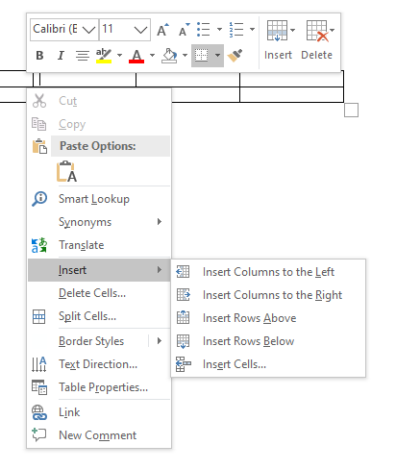

2. In the context menu click Insert option, it will show options to Insert Columns and Rows at different locations of table. Click it to add rows and columns

3. Now we will learn how to delete some rows and columns

4. To delete row and column, Left click and select rows you want to delete or columns. You can also hold shift and click one by one cell to select.

5. Now, right click and open context menu. From context menu, you will find Delete Rows/Columns option. Click it.

6. Selected cells will be deleted

Design your Table:

1. After your table is created, it is time to design it. Click on the table to select it

2. In Menu Bar, Click on Design tab under newly created Table Tools area

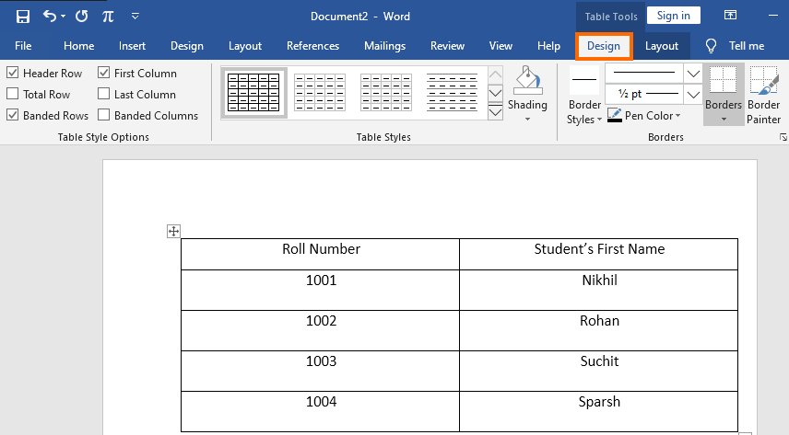

Table Styles:

1. Click on drop down box in Table Styles

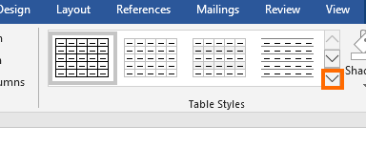

2. It will bring a drop-down menu of pre-defined Table styles to make your table stylish quickly. Click on any one of them and it will be applied to your table

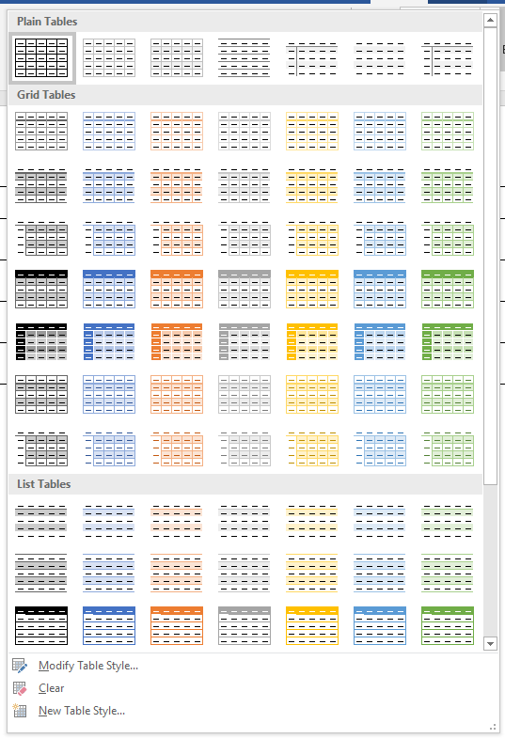

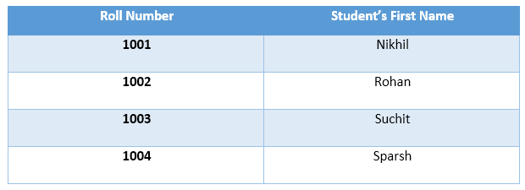

3. However, if you want to add custom style to your table, Click on Modify Table Style in the drop-down menu

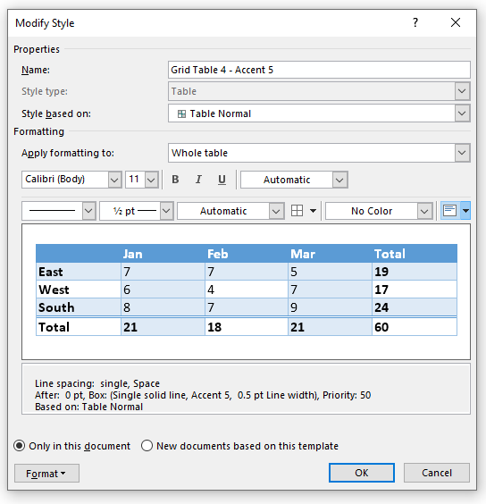

4. Now you can adjust font, cell color in Modify Style menu. After you have changed it click ok. It will apply style to your table.

Draw Table:

Drawing table is almost same as inserting table. But drawing gives you more control over size and appearance of your table.

To draw a table:

1. Click Insert tab from Menu bar, Click on Table button and then click on Draw Table

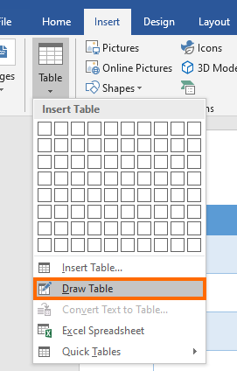

2. After it, your cursor will look like pen. Using pen, you can draw table.

3. To draw, Left click and drag until you feel size will fit table

4. After outline is made, make straight line vertically to make columns and horizontally to make rows

Hyperlink:

Sometimes, we want to add a link of a website or we want to add refer reader to another page. To do this, Word allows user to add hyperlinks, Hyperlinks are text on which if reader clicks. It jumps reader to some other place, webpage, location in document. Hyperlinks are dark blue in color with an under link which changes to purple is user clicks it once. To open a hyperlink, press **Ctr l+ Click** while pointing at hyperlink.

Insert a Hyperlink:

To add a hyperlink:

1. Select the text on which you want to add link

2. Right Click and from context menu, click link (Hyperlink in older versions)

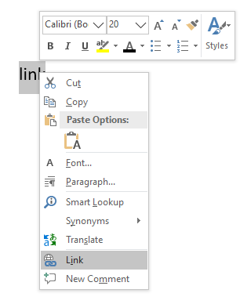

3. Click on Existing File or Web Page to add link. Enter text which you want to be showed in the text box near “Text to display”

4. If you want to add link to a webpage, Enter its URL in the text box near “Address”. Or if you want to open a file using link, Navigate and select file and click OK

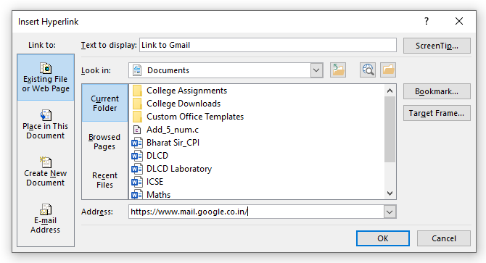

You can also add a link to a page of your document. To do that:

1. In Insert Hyperlink dialog, click “Place in this document” and select the page for link

2. After that, Click OK

Delete a hyperlink:

1. Select the link Text

2. Right click and from context Menu, Click Remove Hyperlink

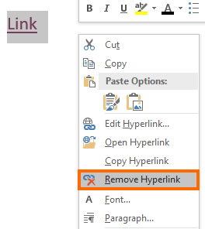

Grammar and Spell check:

While working on documents, we can make many grammatical mistakes, Spelling mistakes. Grammar and Spell check helps us to quickly find out mistakes and correct them also.

To use grammar and spell check:

1. From the Menu Bar, click the Review tab

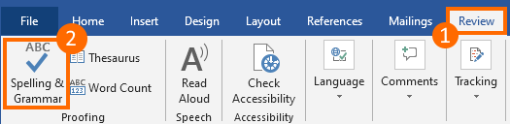2. Then click Spelling & Grammar button at leftmost corner

3. A Side menu of Proofing will appear from right side

4. From the menu, If spelling is wrong or grammatical mistake is valid, Then click on suggested changes or ignore Once to only ignore for current word or ignore all to ignore all words

5. If the word belongs to other language and it doesn’t recognise it as correct. You can also add to dictionary

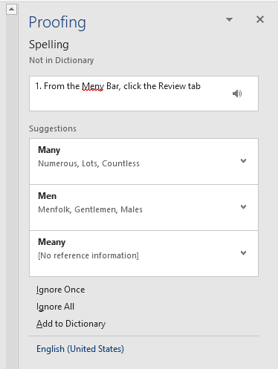

Mail Merge:

Mail Merge is most often used to print or email form letters to multiple recipients. Using Mail Merge, you can easily customize from letters for individual recipients. Mail merge is also used to create envelopes or labels in bulk.

How to use Mail Merge:

1. In your document, From Menu Bar click on Mailings tab then click “Start Mail Merge”

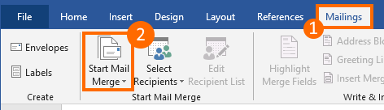

2. After clicking Start Mail Merge, from drop-down menu click Step-by-Step Mail Merge Wizard

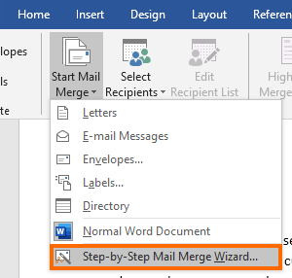

3. Select the document type from Letters, E-mail messages, Envelopes… and then click Next: Start document

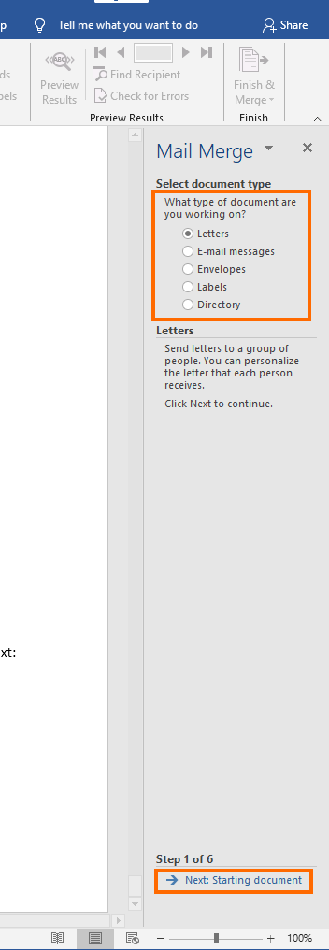

4. Select the starting document. From given options: Use current document, start from a template or Start from existing document. Select and click Next

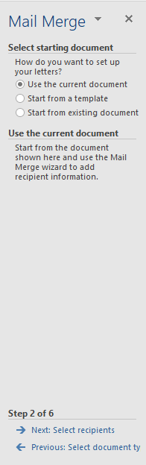

5. Select recipients you already used or click Create to add names and address

6. If you’re creating new list, A dialog box will appear. You can write Name, Address, email of your recipient. You can add more rows by clicking “New Entry”

7. After making list, Click OK and Next in Mail Merge menu

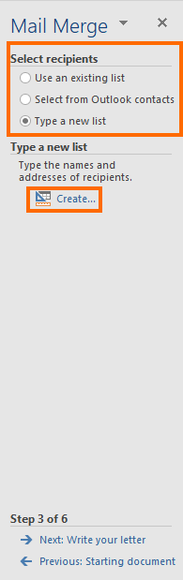

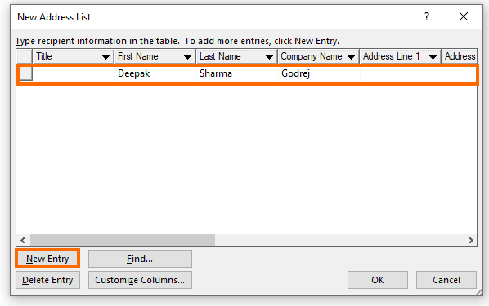

8. Now, you can choose starting Address block and Greeting time from option. Word will automatically write it for you in the document

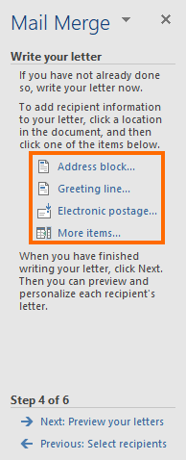

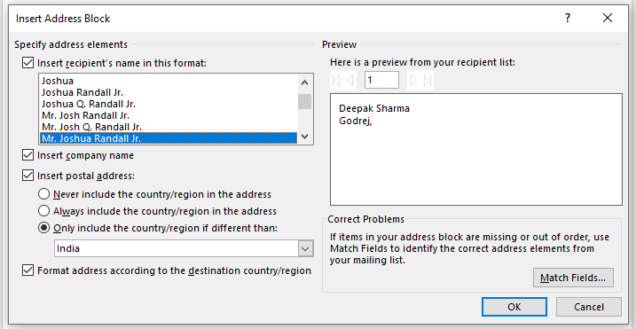

9. Now it will prompt you for previewing your letters, so you can check how they will appear after being sent and gives you an option to edit recipient list

10. Click Next to complete wizard and then Print to print your document

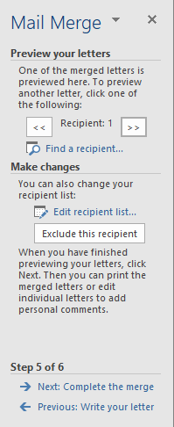

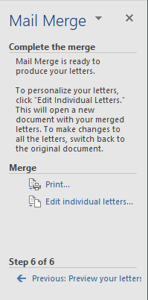

Chapter 2

Introduction to Microsoft Excel and its functions

Introduction

A spreadsheet is a versatile computer program (package) that enables you to do a wide range of calculations dynamically, and create high quality graphs and charts. Microsoft Excel is the most widely used spreadsheet, and is available within the Microsoft Office suite of programs.

A spreadsheet works by laying out your data in a rectangular grid of rows and columns, in the same way that you would do if you were using a sheet of paper. The point where a row and column meet are called a cell. Any cell in the spreadsheet is identified by its column and row position.

Formulas and functions

Overview of formulas in Excel:

To create a formula with basic operation, we follow these steps:

1. Select a cell
2. Type the equal sign =
3. Select a cell or type its address in the selected cell

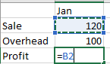

1. Enter an operator. For example, – for subtraction
2. Select the next cell, or type its address in the selected cell

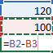

1. Press Enter. The result of the calculation appears in the cell with the formula

To create a formula with built-in function, we follow these steps:

1. Select an empty cell
2. Type an equal sign = and then type a function. For example, =SUM for getting the total sales
3. Type an opening parenthesis (
4. Select the range of cells, and then type a closing parenthesis)

range

1. Press Enter to get the result

Parts of Excel formula:

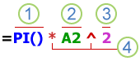

1. Functions: The [PI() function](https://support.microsoft.com/en-us/office/pi-function-264199d0-a3ba-46b8-975a-c4a04608989b) returns the value of pi: 3.142...
2. References: A2 returns the value in cell A2
3. Constants: Numbers or text values entered directly into a formula, such as 2
4. Operators: The ^ (caret) operator raises a number to a power, and the * (asterisk) operator multiplies numbers

Most common built-in functions in Excel:

1. SUM function:

The SUM function adds values. You can add individual values, cell references or ranges or a mix of all three.

For example:

**=SUM(A2:A10)** Adds the values in cells **A2:10**.

1. AVERAGE function:

The SUM function returns the average (arithmetic mean) of the arguments.

For example:

If the range **A1:A20** contains numbers, the formula **=AVERAGE(A1:A20)** returns the average of those numbers

1. IF function:

The IF function is one of the most popular functions in Excel, and it allows you to make logical comparisons between a value and what you expect. So, an IF statement can have two results. The first result is if your comparison is True, the second if your comparison is False.

For example:

**=IF(C2=”Yes”,1,2)** says IF(C2 = Yes, then return a 1, otherwise return a 2)

1. SUMIF function:

You use the **SUMIF** function to sum the values in a range that meet criteria that you specify.

For example:

Suppose that in a column that contains numbers, you want to sum only the values that are larger than 5. You can use the following formula: **=SUMIF(B2:B25,">5")**

1. COUNTIF function:

Use COUNTIF, one of the [statistical functions](https://support.microsoft.com/en-us/office/statistical-functions-reference-624dac86-a375-4435-bc25-76d659719ffd), to count the number of cells that meet a criterion

In simple terms, COUNTIF says:

=COUNTIF(Where do you want to look?, What do you want to look for?)

For example:

**=COUNTIF(A2:A5,"London")**

1. COUNT function:

The **COUNT** function counts the number of cells that contain numbers, and counts numbers within the list of arguments. Use the **COUNT** function to get the number of entries in a number field that is in a range or array of numbers.

For example:

To count the numbers in the range A1:A20: **=COUNT(A1:A20)**. In this example, if five of the cells in the range contain numbers, the result is **5**.

1. AVERAGE function:

The SUM function returns the average (arithmetic mean) of the arguments.

For example:

If the range **A1:A20** contains numbers, the formula **=AVERAGE(A1:A20)** returns the average of those numbers

1. COUNTA function:

The **COUNTA** function counts the number of cells that are not empty in a range.

For example:

If the range **A1:A20** contains numbers, the formula **=AVERAGE(A1:A20)** returns the average of those numbers

| **Data** |  |  |
| --- | --- | --- |
| 39790 |  |  |
| 19 |  |  |
| 22.24 |  |  |
| TRUE |  |  |
| #DIV/0! |  |  |

**=COUNTA(A2:A7)** counts the number of nonblank cells in cells A2 through A7 and returns answer 5

1. LOOKUP function:

Use LOOKUP, one of the [lookup and reference functions](https://support.microsoft.com/en-us/office/excel-functions-by-category-5f91f4e9-7b42-46d2-9bd1-63f26a86c0eb#__toc309306714), when you need to look in a single row or column and find a value from the same position in a second row or column.

For example:  Let's assume you know the part number for an auto part, but you don't know the price. You can use the LOOKUP function to return the price in cell H2 when you enter the auto part number in cell H1

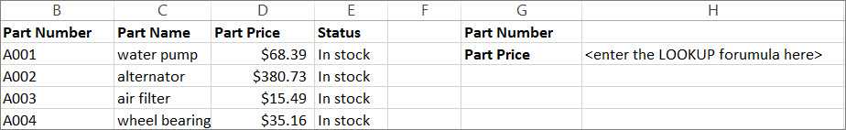

Use the LOOKUP function to search one row or one column. In the above example, we're searching prices in column D.

1. VLOOKUP function:

Use VLOOKUP when you need to find things in a table or a range by row.

In simple form, the VLOOKUP function says:

=VLOOKUP(What you want to look up, where you want to look for it, the column number in the range containing the value to return, return an Approximate or Exact match – indicated as 1/TRUE, or 0/FALSE).

For example:

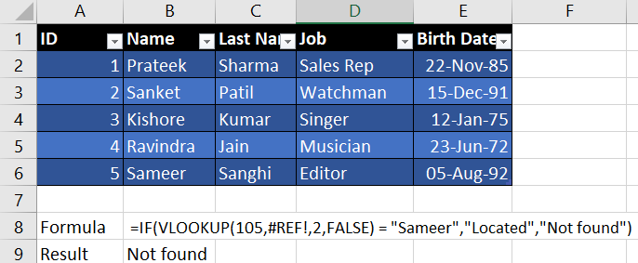

1. TRIM function:

It removes all spaces from text except for single spaces between words. Use TRIM on text that you have received from another application that may have irregular spacing.

For example:

**=TRIM(" First Quarter Earnings ")** removes leading and trailing spaces from the text in the formula (First Quarter Earnings).

1. MIN function:

Min function returns the smallest number in a set of values.

For example:

| **Data** |  |  |
| --- | --- | --- |
| 10 |  |  |
| 7 |  |  |
| 9 |  |  |
| 27 |  |  |
| 2 |  |  |

**=MIN(A2:A6)** returns smallest of the numbers in the range A2:A6 which is 2.

1. MAX function:

Max function returns the largest number in a set of values.

For example:

| **Data** |  |  |
| --- | --- | --- |
| 10 |  |  |
| 7 |  |  |
| 9 |  |  |
| 27 |  |  |
| 2 |  |  |

**=MAX(A2:A6)** returns largest of the numbers in the range A2:A6 which is 27.

1. DATE function:

The **DATE** function returns the sequential serial number that represents a particular date.

**Syntax:** DATE(year,month,day)

For example:

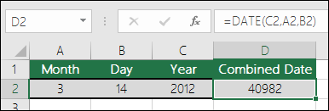

**=DATE(C2,A2,B2)** combines the year from cell C2, the month from cell A2, and the day from cell B2 and puts them into one cell as a date. The example below shows the final result in cell D2.

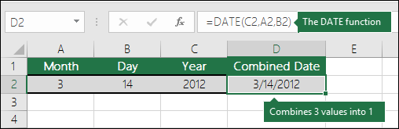

1. DAY function:

Returns the day of a date, represented by a serial number. The day is given as an integer ranging from 1 to 31.

**Syntax:** DAY(serial_number)

For example:

**=DAY(A2)** shows day of the date in cell A2 (15)

1. DAYS function:

Returns the number of days between two dates.

**Syntax:** DAYS(end_date, start_date)

For example:

**=DAYS(A2,A3)** finds the number of days between the end date in A2 and the start date in A3 (364).

1. NOW function:

Returns the serial number of the current date and time. If the cell format was General before the function was entered, Excel changes the cell format so that it matches the date and time format of your regional settings. You can change the date and time format for the cell by using the commands in the Number group of the Home tab on the Ribbon.

The NOW function is useful when you need to display the current date and time on a worksheet or calculate a value based on the current date and time, and have that value updated each time you open the worksheet.

**Syntax:** NOW(), NOW()+<integer number>, NOW()-<integer number>

For example:

**=NOW()** Returns current date **5/2/2021** and **NOW()+1.5** returns date and time **1 day and 12 hours later**

1. ROUND function:

The ROUND function rounds a number to a specified number of digits.

For example:

If cell A1 contains 23.7825, and you want to round that value to two decimal places, you can use the following formula:

**=ROUND(A1, 2)**

1. ROUNDUP function:

The ROUNDUP function rounds a number up, away from 0

For example:

**=ROUNDUP(3.2,0)** Rounds number **3.2** up to zero decimal places and gives 4 as result

1. ROUNDDOWN function:

The ROUNDDOWN function rounds a number down, away from 0

For example:

**=ROUNDDOWN(3.2,0)** rounds number **3.2** down to zero decimal places and gives 3 as result

Printing a workbook or sheet

### Print one or several worksheets

1. Select the worksheets that you want to print.
2. Click **File** > **Print**, or press CTRL+P.
3. Click the **Print** button or adjust **Settings** before you click the **Print** button

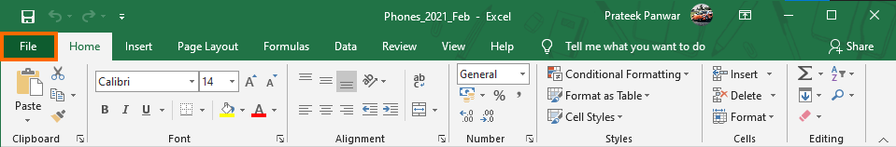

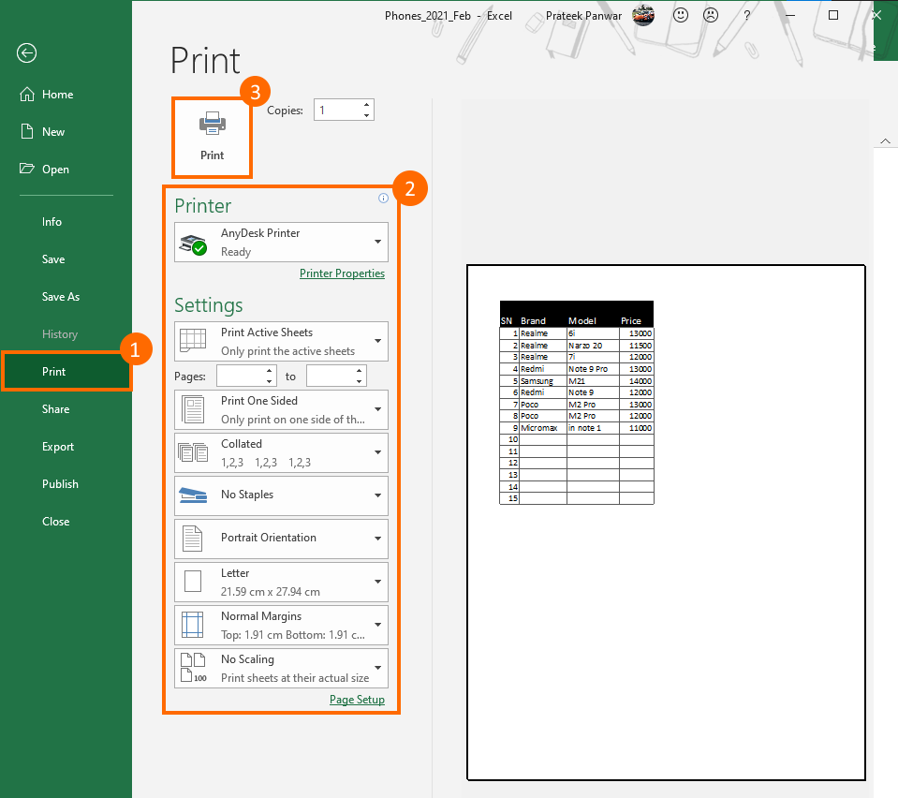

### Print all or part of a worksheet

1. Click the worksheet, and then select the range of data that you want to print
2. Click **File**, and then click **Print**
3. Under **Settings**, click the arrow next to **Print** **Active** **Sheets** and select the appropriate option

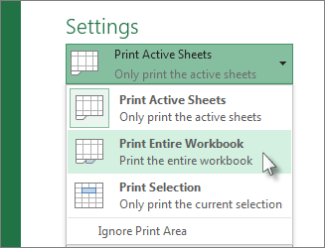

1. Click Print

Print an Excel table

1. Click a cell within the table to enable the table.
2. Click **File**, and then click **Print**.
3. Under **Settings**, click the arrow next to **Print Active Sheets** and select **Print Selected Table**.
4. 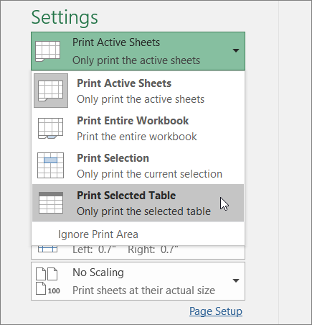Click **Print**.

Print a workbook to a file

1. Click **File**, and then click **Print**, or press Ctrl+P.
2. Under **Printer**, select **Print to File**.

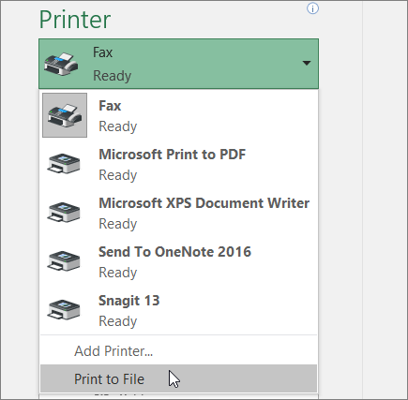

1. Click **Print.**
2. In the **Save Print Output As** dialog box, enter a file name and then click **OK**. The file will be saved in your *Documents* folder

Chapter 3

Introduction to PowerPoint and its functions

